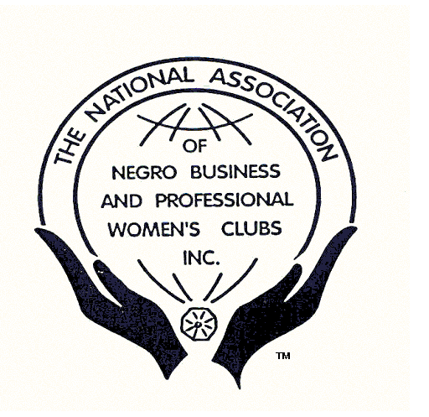
The National Association of
Negro Business and Professional Women’s Clubs Inc.
1806 New Hampshire Ave. NW ◊ Washington, DC 20009-3206 ◊ 202-483-4206 ◊ 202-462-7253 (fax)
E-mail: membership@nanbpwc.org ◊ Website: http://www.nanbpwc.org

OMBUDSMEN MEMBERSHIP APPLICATION
(Males 18 and above)
Personal Information
Club Name: |  | District: |  | Name: | Last: |  | First: |  | Middle:
Home Address: |  |  |  |  | City: |  | State: | Zip Code:
Telephone: | Cell: |  | This is: Home Work |  |  | E-Mail Address:
This information is not required but provides information to assist the Association in identifying skills and experience that can be supportive of our mission.

Business or Occupation – Check One
I am a Business Owner/Entrepreneur Business Name _____________________________________

I am a Professional Occupation_________________________________________
(including computer technology, management professional degrees).

Organizational Affiliations:
Name: |  |  | City: |  |  |  | Office Held:
Name: |  |  | City: |  |  |  | Office Held:
List special skills or interests:
Sponsor |  |  |  |  | Sponsor’s  Club
District Website Contact |  |  |  |  | National Website Contact
References:
Name |  |  | Address |  |  | Telephone
Name |  |  | Address |  |  | Telephone
Signatures:
Applicant: |  |  |  |  |  |  |  | Date
Acceptance: |  | Local President/Membership Chair |  |  |  |  |  | Date
Approval: |  | Governor/Vice Governor: |  |  |  |  |  | Date
Club Instructions: After receiving signature of District Governor, submit original application, national Headquarters, 1806 New Hampshire NW, Washington, DC 20009.
Office Use: | Fees Received: | Date | Amount | $
 | Posted to Database: |  | Member Packet Sent:

Revised 8/2021

